**Applied Materials**

**Global Information Services**

*I0014650*

*MDP SBU Actions Requirement*

Business Requirements Document (BRD)

**How to use this Template – Instructions:**

* This template contains instructions and examples in blue italics
* When creating a project deliverable from this template, replace the instructions or examples with your specific information. Also change the font style to Normal without italic
* This document is designed for multiple project types. If any section of this template is not applicable to your project, please delete
* Feel free to add additional sections if required to best meet the needs of your project objectives
* Change the header text to reflect the project name
* Do not change the footer information. These are pre-defined for copyright information, PMM template versioning purposes
* All the dates should be in mm/dd/yy format

**Project Document Version History**

|  |  |  |  |  |
| --- | --- | --- | --- | --- |
| **Version No.** | **Date** <mm/dd/yy> | **Prepared by/ Updated by** | **Changes Made** | **Status** |
| 0.1 | 06/19/2017 | Zara Ahmed Durrani | First Draft | In Progress |
| 1.0 | 06/19/2017 | Prasanna Ajrikailaje | Reviewed document | Completed |

**Project Document Distribution List**

|  |  |  |
| --- | --- | --- |
| **Name** | **Role** | **Action/Information** |
| Rachel Yap | *Customer / Process Owner* | *Responsible* |
|  | *Domain Manager* | *Responsible* |
|  | *Functional Lead* | *Responsible* |
| Prasanna Ajrikailaje | *Project Manager* | *Accountable* |
|  | *BCP / DRP Analyst* | *Consulted* |
|  | *Data Architect* | *Consulted* |
|  | *Database Administrator (DBA)* | *Consulted* |
|  | *Risk Representative* | *Consulted* |
|  | *Information Security Architect* | *Consulted* |
|  | *Integration Architect* | *Consulted* |
|  | *Performance Analyst* | *Consulted* |
|  | *Procurement Analyst* | *Consulted* |
|  | *Production Services Lead* | *Consulted* |
|  | *Quality Consultant* | *Consulted* |
|  | *Release/ Migration Analyst* | *Consulted* |
| Zara Ahmed Durrani | *Software Engineer* | *Consulted* |

**Cross-Reference Documents**

|  |  |  |
| --- | --- | --- |
| **Document Name** | **Document Version** | **Document Location** |
| MDPSBU Excel Report Update - 2017-05-10 |  |  |

**TABLE OF CONTENTS**

1 INTRODUCTION 4

1.1 Purpose of this Document 4

1.2 Scope of this Document 4

1.3 Business Process 4

1.3.1 As-is Business Process 4

1.3.2 To-be Business process 4

1.4 Acronyms and Definitions 5

2 FUNCTIONAL REQUIREMENTS 6

2.1 Changes to update “Project Reviews Form” 6

2.2 Changes to update “Action Reviews Form”. 6

2.3 Changes to update the “Status Report” sent out every Monday. 8

2.4 Changes to update “Completed Action” email notification 8

2.5 Changes to update the owners list 9

3 NON-FUNCTIONAL REQUIREMENTS 9

3.1 Assumptions 9

3.2 Service Level Requirements 9

3.3 Availability Requirements 9

3.4 Performance Requirements 9

3.5 Security Requirements 9

3.6 Sensitive Data Requirements 9

3.7 Trade Control Requirements 9

3.8 Retention/ Archival Requirements 9

3.9 Geographical Requirements 10

3.10 Volume Requirements 10

3.11 Data Conversion Requirements 10

3.12 Deployment Requirements 10

3.13 Documentation Requirements 10

3.14 User Training Requirements 10

3.15 Other Requirements 10

# INTRODUCTION

## Purpose of this Document

The purpose of this document is to detail the changes requested on existing “MDP SBU Actions” application.

## Scope of this Document

Scope of this BRD is limited to:

* Changes to update “Project Reviews Form”.
* Changes to update “Action Reviews Form”.
* Changes to update the “Status Report” sent out every Monday to reset certain values.
* Changes to update “Completed Action” email notification

## Business Process

### As-is Business Process

At present, the application is used by end users to maintain the status and other attributes of various Projects and Action items pertaining to each individual project.

### To-be Business process

The new system should be same as the existing system but the below functionalities will be included:

1. Changes to update “Project Reviews Form”.
   * Remove Open Entries Project Name, Revise Project Name with dropdown option.
   * Remove Project Type, Project Status and Project Owner
   * No number for projects.
   * Eliminate Ad Hoc Projects and replace with "Others".
   * No Created date for projects.
   * Restrict Project Edits to Adam and Rachel, Ron Hamada (Admin access)
2. Changes to update “Action Reviews Form”.
   * Description goes away
   * Priority "Low" goes away.
   * Summary to move up - under Status Update.
   * GOT code, KPU, Tool Selection, SA, IB Selection only available when select Service or Field Service Support.
   * Remove WIP and keep Open in the Status dropdown.
   * Remove Incremental $ <Current FY Revenue>.
   * Add Project Owner above Action Owner.
3. Changes to update the “Status Report” sent out every Monday to reset certain values.
4. Changes to update “Completed Action” email notification
5. Changes to update the owners list (Remove Benjamin Dang & Tom McCarthy, add in Dave Sciortino, Ronald Hamada)

## Acronyms and Definitions

|  |  |
| --- | --- |
| **Acronym** | **Definition** |
| SA | Service Agreement |
| SP | SharePoint |
| BRD | Business Requirement Document |
| AMT | Applied Materials |

# FUNCTIONAL REQUIREMENTS

## Changes to update “Project Reviews Form”

* Remove Open Entries Project Name, Revise Project Name with dropdown option.
* Remove Project Type, Project Status and Project Owner
* No number for projects.
* Eliminate Ad Hoc Projects and replace with "Others".
* No Created date for projects.
* Restrict Project Edits to Adam and Rachel, Ron Hamada (Admin access)

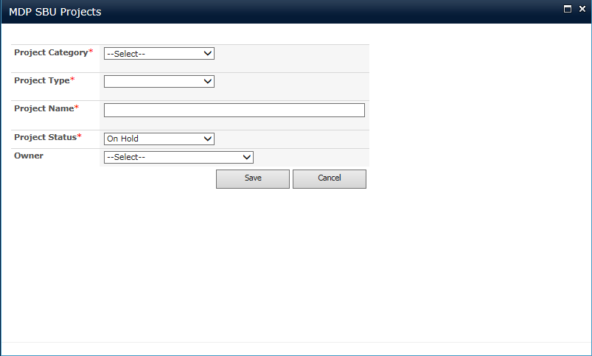

## Changes to update “Action Reviews Form”.

* Description goes away
* Priority "Low" goes away.
* Summary to move up - under Status Update.
* GOT code, KPU, Tool Selection, SA, IB Selection only available when select Service or Field Service Support.
* Remove WIP and keep Open in the Status dropdown.
* Remove Incremental $ <Current FY Revenue>.
* Add Project Owner above Action Owner.

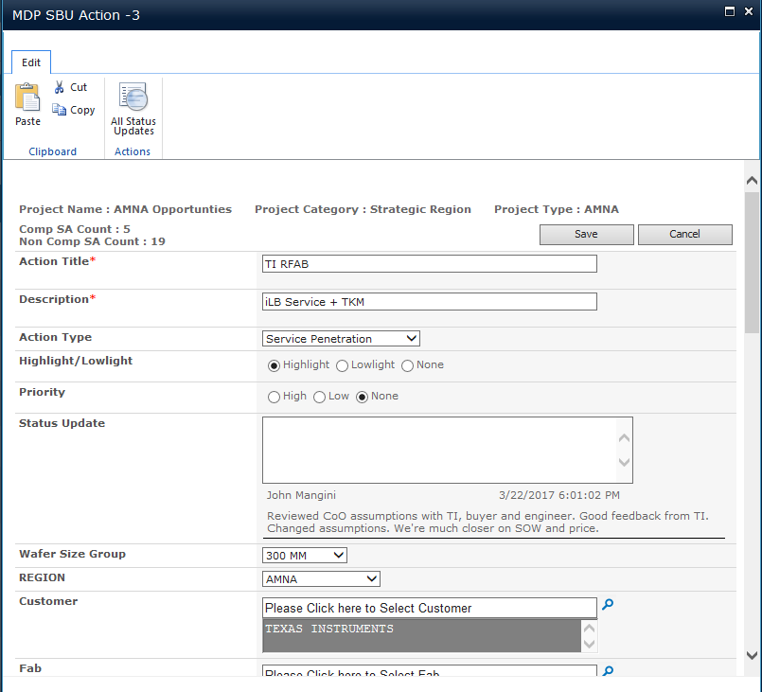

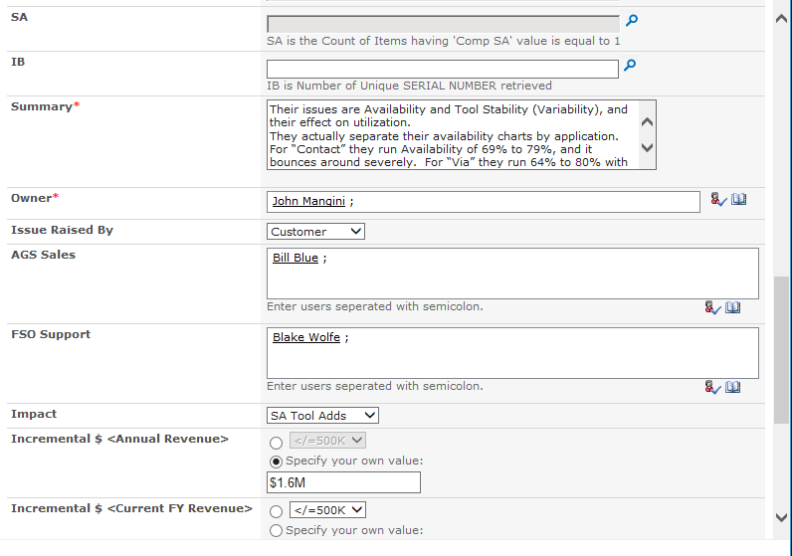

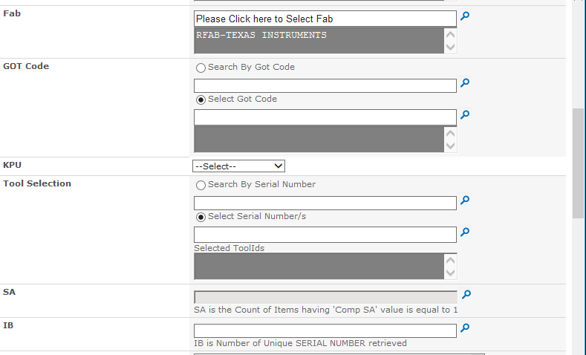 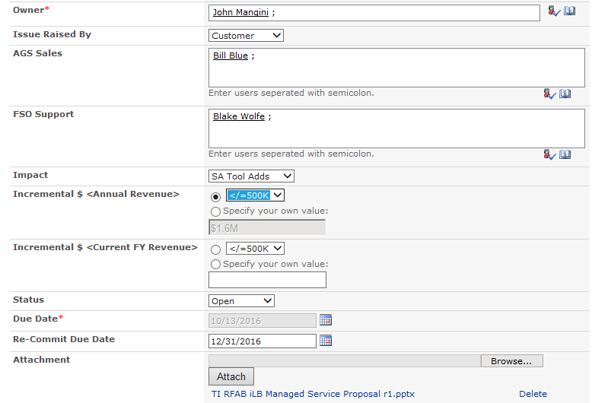

## Changes to update the “Status Report” sent out every Monday.

* Reset Highlight/ Lowlight and Priority after report send out every week on Monday morning SCLA time for both Updated and Not Updated reports.

## Changes to update “Completed Action” email notification

* Status: Manager will have an email notification on Completed Action. Include an option for "Closed Action" in the email "Yes" or "No".
  + "If manager select "Yes", Status in SharePoint page for this action will changed to “Closed".
  + "If manager select "No", link the page to "Status Update" for manager to include comment". Status in SharePoint page for this action will change to “Open".

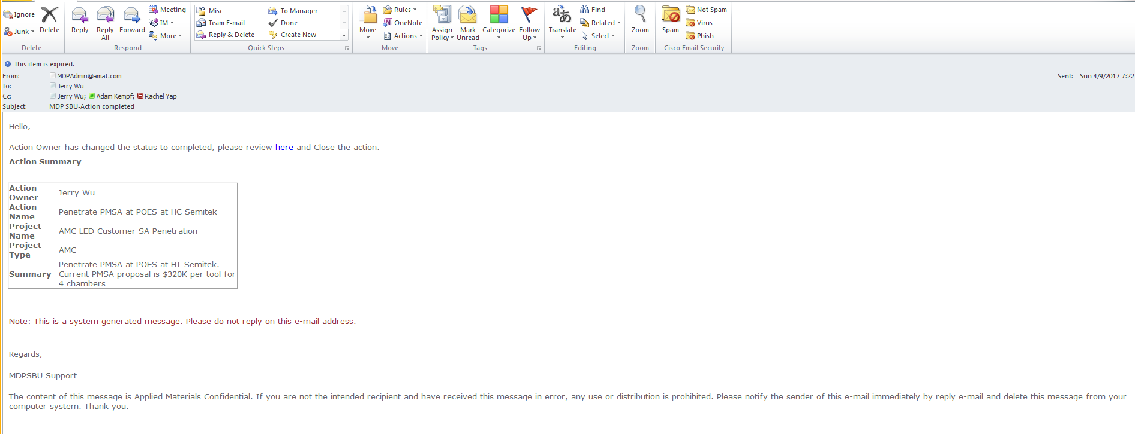

## Changes to update the owners list

* Remove Benjamin Dang & Tom McCarthy, add in Dave Sciortino, Ronald Hamada

# NON-FUNCTIONAL REQUIREMENTS

## Assumptions

The existing functionality in the MDP SBU site have been setup as per requirement and the system works as expected.

## Service Level Requirements

Standard SharePoint SLA

## Availability Requirements

24/7 up time with standard maintenance window.

## Performance Requirements

No additional requirements.

## Security Requirements

* Users in AMAT Domain will only have access to the system.
* Request level security will be maintained by groups and request status

## Sensitive Data Requirements

N/A

## Trade Control Requirements

N/A

## Retention/ Archival Requirements

## Geographical Requirements

This application must be available globally. There will be no external users outside of the AMAT network.

## Volume Requirements

N/A

## Data Conversion Requirements

N/A

## Deployment Requirements

N/A

## Documentation Requirements

PMM compulsory deliverables to be produced by all the GIS projects as specified in the PMM Scaling Document. This is mandatory.

## User Training Requirements

N/A

## Other Requirements

N/A